What’s the Buzz?

One-day PROFESSIONAL WTB TRAINING
with Mark Le Messurier and Noni Le Messurier
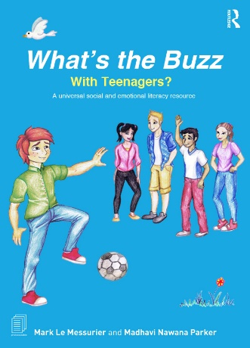
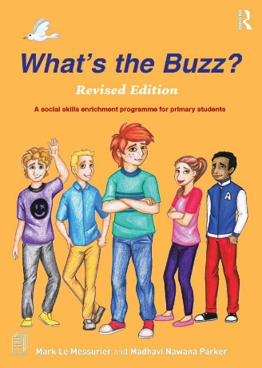
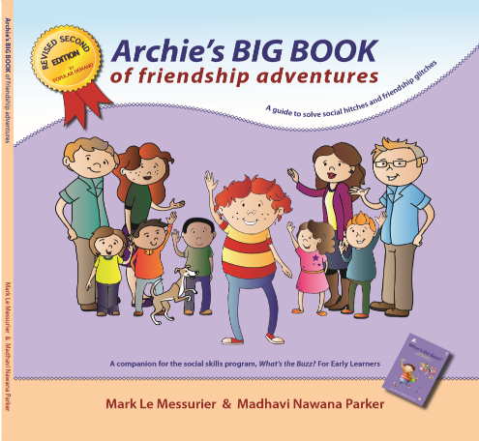
at Fullarton Park Community Centre (face to face)

Training Day opportunities available in 2026:
Friday 27th February (Term 1, face to face)
Friday 22nd May (Term 2, face to face)
Friday 21st August (Term 3, face to face)
Friday 6th November (Term 4, face to face)

What's the Buzz? is a complete social and emotional literacy (SEL) approach comprised of 48 lessons and easy to use guided conversations over 3 programs;

What's the Buzz? for EARLY LEARNERS - 16 lessons - (ages 5 to 8 years)
What's the Buzz? for PRIMARY STUDENTS - 16 lessons - (ages 9 to 11 years)
What's the Buzz? with TEENAGERS - 16 lessons - (ages 12 to 15 years)

This evidence-based program teaches young people social and emotional intelligence and is complimented by a deep selection of online resources. The program has also become a required text for teachers, counsellors, parents, psychologists, social workers and youth workers in training at many Universities worldwide.

It is a flexible Positive Education approach based on neuroaffirming principles where individuals come together, in a safe, structured environment to have fun, learn, exchange ideas, and to understand the beauty of each other’s diversity. 'What's the Buzz?' embraces that all human beings experience the social and emotional world differently and have the right to express their feelings and actions in their own, compassionate, way. No one prescriptive way is ever right. Our goal – “There’s 100’s of social and emotional issues that crop up in life, and there are 100’s of ways to work assertively, and kindly, with them.”

Twelve years on, after many second editions, ‘What's the Buzz?’ is now being used daily in more than 140 countries.

PD Certificates, PowerPoints and comprehensive notes issued on completion

REGISTRATION - complete the form on the following page and return the Word doc. to Elissa via email at registrations@marklemessurier.com.au or elissa@nonilemessurier.com.au
What’s the Buzz?
ABN: 19 642 144 750
69 Goodwood Road
Wayville SA 5034
P: 0411 343 574
E: registrations@marklemessurier.com.au
W: www.whatsthebuzz.net.au

REGISTRATION FORM
One-day PROFESSIONAL WTB TRAINING
with Mark Le Messurier and Noni Le Messurier
at Fullarton Park Community Centre (face to face)
PERSONAL DETAILS
First Name
Surname
School/Business Name
Postal Address (if invoicing self)
Mobile number
Email | Work
Email | Personal*
INVOICE/FINANCE OFFICER DETAILS
Finance Officer Name
Business Postal Address
Finance Officer Email
* Please provide a personal email to ensure you receive all correspondence. We’ve learnt from experience that some school severs will block emails with attachments.

Nominate ONE Training Day date:
Friday 27th February (Term 1, face to face)
Friday 22nd May (Term 2, face to face)
Friday 21st August (Term 3, face to face)
Friday 6th November (Term 4, face to face)

Total Cost (face to face): $350 per person (incl. GST) *group discounts available

Please return this form via email to Elissa at registrations@marklemessurier.com.au who will confirm your registration and issue an invoice. Once payment is received, your position is secure and Elissa will email any pre-reading and support information for the event, as well as a detailed overview of the Training Day.
This is a COVID-19 safe event. The usual protocols will be followed, such as appropriate distancing, sanitisation and face masks when necessary. We assume that your attendance indicates that you are feeling well and unlikely to have COVID-19.

Conditions and Cancellation Policy
Invoice MUST BE settled ONE WEEK before the Training Day, otherwise participation will not occur.
Cancellation 6 days prior to event – 25% cost retained. Cancelation less than 4 days prior to event – 50% cost retained.
Cancelation less than 48 hours prior to event – Non-refundable.

